## Image gallery

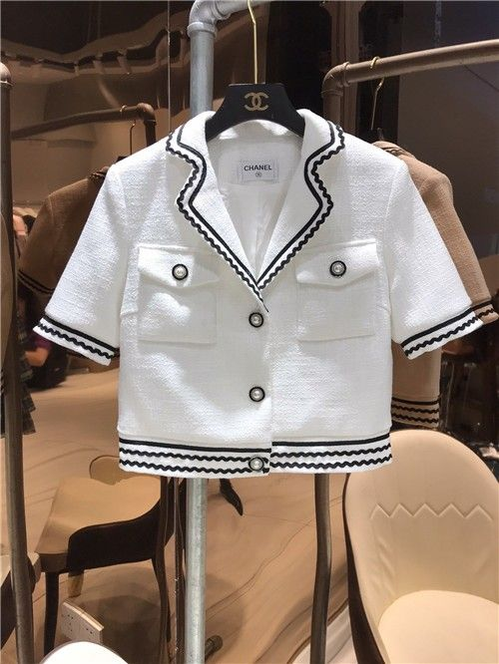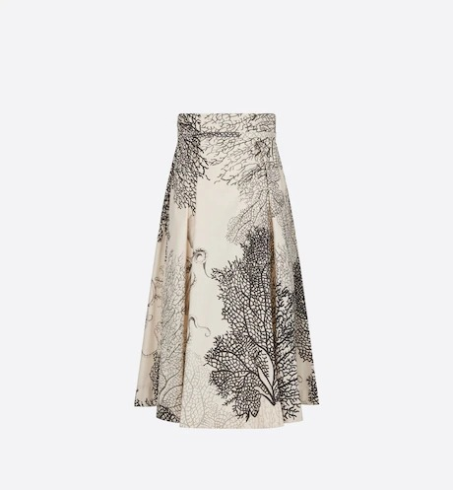

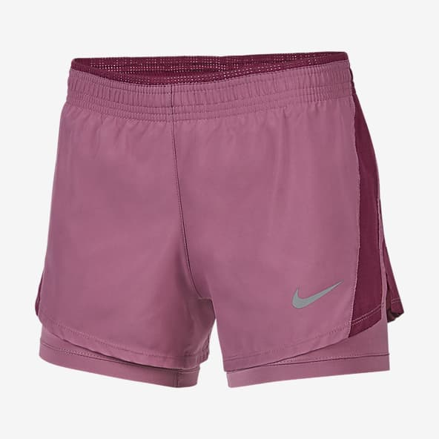

Short beach windbreaker in "Tatersales" printed technical canvas (100% polyamide)  
  
- High collar with hood storage  
- Middle front fastening with lacquered zip  
- Side pockets  
- Velcro® fitted cuffs  
- Hood with elastic drawstrings  
- Round pearl and cord lock in rubber  
  
Made in Italy  
  
This piece runs true-to-size.

Back length: 21.3" | The dimensions indicated correspond to a size 38.